March 6, 2012

To Whom It May Concern:

4" through 12" injection molded gasketed SDR 35 sewer fittings shall be manufactured in accordance with ASTM D3034, ASTM F1336, and CSA B182.2. They shall be injection molded from virgin PVC compound having a cell classification of 12454 or 13343 in accordance with, and certified by the National Sanitation Foundation (NSF), to meet ASTM D1784. Gaskets shall be manufactured in accordance with ASTM F477 or ASTM F913. Gaskets shall be firmly seated in fitting in order to ensure proper installation and to prevent dislocation or misalignment during system assembly. Gasket joints must comply with ASTM D3212 Internal Pressure Test (exfiltration) and Vacuum Test (infiltration) at 5 degrees of gasket joint deflection.
Gasketed SDR 35 sewer fittings shall be certified by the National Sanitation Foundation (NSF) and, in applicable configurations, by the International Association of Plumbing and Municipal Officials (IAPMO) to meet ASTM D3034, and by the Canadian Standards Association (CSA) to meet CSA B182.2.

Sincerely,
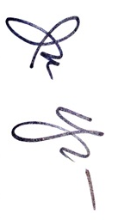
Jon Houghton
Director of Fittings – North America
NAPCO

